Computer Language Coding Concepts

Object Get & Set in a Diagram
The concept of object Get and Set is explained in the article Object Get & Set. The current article demonstrates their expression in a diagram.

The system members Object . ID, Object . Get and Object . Set are part of the system interface of a related item or related list item and displayed in a diagram as follows:

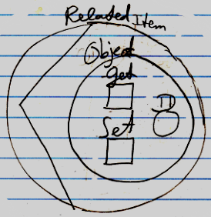

So the Object part of the system interface contains the members ID, Get and Set.

The contents of the object, the related item points to, will probably not be visible inside the related object symbol when the system interface is opened up. Instead, the contents of the object might be shown inside the Object . ID member of the system interface.

See also: System Objects, Interface in a Diagram (may not be written yet)

Author & Copyright: Jan-Joost van Zon Date: July 18, 2008 – July 18, 2008 Location: Oosterhout, The Netherlands Status: Finished

